***COMPLEX MAPPINGS***

****1.Merging Input from Multiple Sources:****

You may have multiple elements in the Process Data that you wish to map to one repeating element in the Activity Input. For example, you may have multiple formats for **menu** records and you wish to create a single, merged mailing list containing all **breakfast_menu** in one format. In this example as following below.

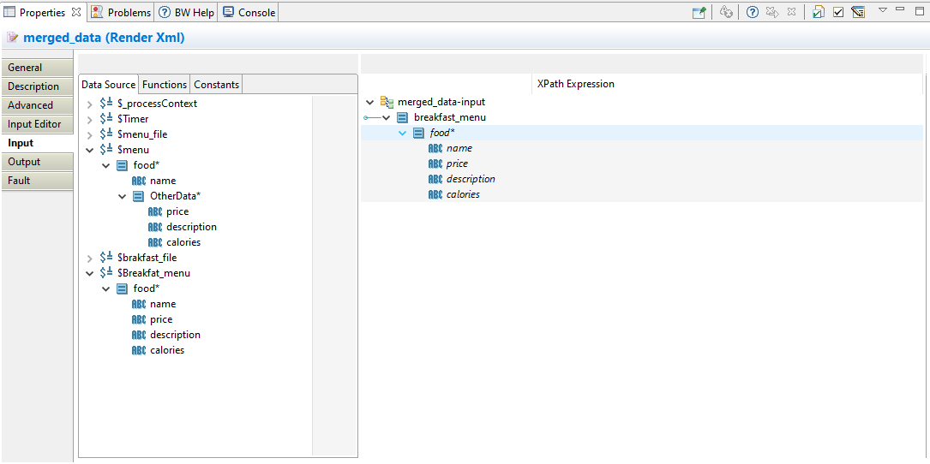

1. configured these schemas already in parsexml activities as below.

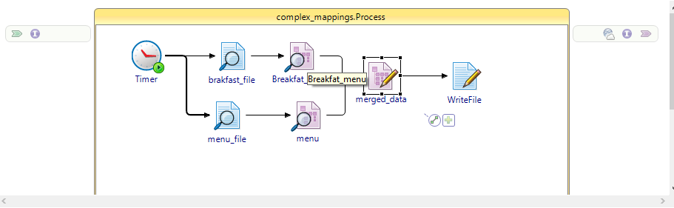

1. Break_fast xml schema as configured below.

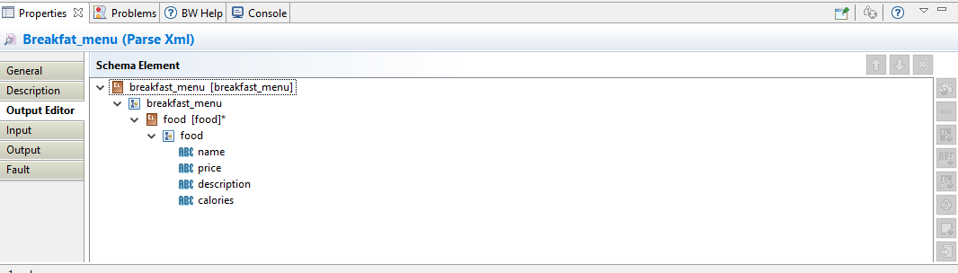

1. menu xml schema as configured below.

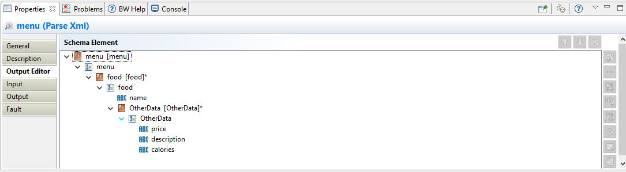

1. In break_fast read file taken data as below.

<breakfast_menu>

<food>

<name>Belgian Waffles</name>

<price>$5.95</price>

<description>Two of our famous Belgian Waffles with plenty of real maple syrup</description>

<calories>650</calories>

</food>

<food>

<name>Strawberry Belgian Waffles</name>

<price>$7.95</price>

<description>Light Belgian waffles covered with strawberries and whipped cream</description>

<calories>900</calories>

</food>

<food>

<name>Berry-Berry Belgian Waffles</name>

<price>$8.95</price>

<description>Light Belgian waffles covered with an assortment of fresh berries and whipped cream</description>

<calories>900</calories>

</food>

<food>

<name>French Toast</name>

<price>$4.50</price>

<description>Thick slices made from our homemade sourdough bread</description>

<calories>600</calories>

</food>

<food>

<name>Homestyle Breakfast</name>

<price>$6.95</price>

<description>Two eggs, bacon or sausage, toast, and our ever-popular hash browns</description>

<calories>950</calories>

</food>

</breakfast_menu>

1. in menu taken data as below.

<menu>

<food>

<name>Waffles</name>

<OtherData>

<price>$5.95</price>

<description>Two of our famous Belgian Waffles with plenty of real maple syrup</description>

<calories>650</calories>

</OtherData>

</food>

<food>

<name>Strawberry</name>

<OtherData>

<price>$7.95</price>

<description>Light Belgian waffles covered with strawberries and whipped cream</description>

<calories>900</calories>

</OtherData>

</food>

<food>

<name>Berry-Berry</name>

<OtherData>

<price>$8.95</price>

<description>Light Belgian waffles covered with an assortment of fresh berries and whipped cream</description>

<calories>900</calories>

</OtherData>

</food>

<food>

<name>French</name>

<OtherData>

<price>$4.50</price>

<description>Thick slices made from our homemade sourdough bread</description>

<calories>600</calories>

</OtherData>

</food>

<food>

<name>LITE Breakfast</name>

<OtherData>

<price>$6.95</price>

<description>Two eggs, bacon or sausage, toast, and our ever-popular hash browns</description>

<calories>950</calories>

</OtherData>

</food>

</menu>

***The following procedure describes how to map multiple elements into a single repeating element.***

$1 Select the repeating element in the Activity Input area, right-click, and select Duplicate from the popup menu.

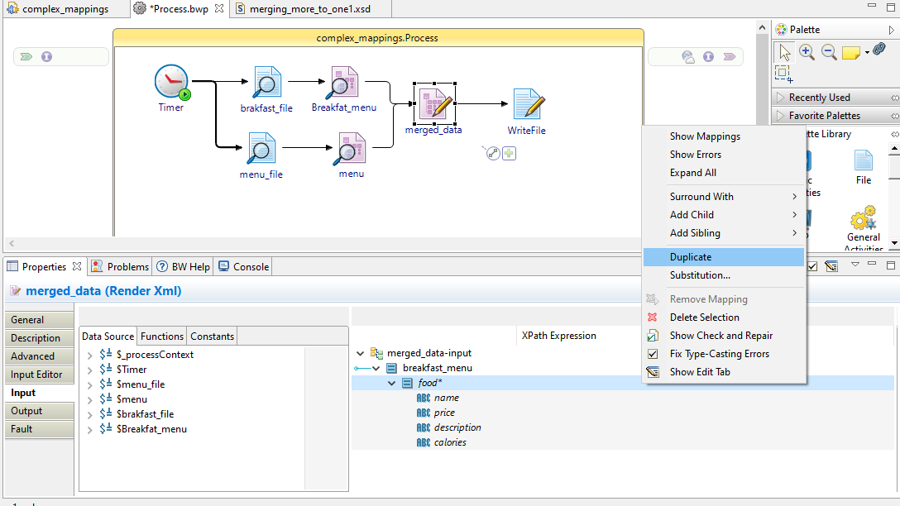

Because you are creating two different formulas for mapping, you need two copies of the repeating element, one for each format. The resulting output contains only one repeating customer element, but the two copies in the Activity Input area make it simpler to perform two different mappings.

# 2 Map one of the elements from the Process Data to the first copy of the repeating element in the activity input As below.

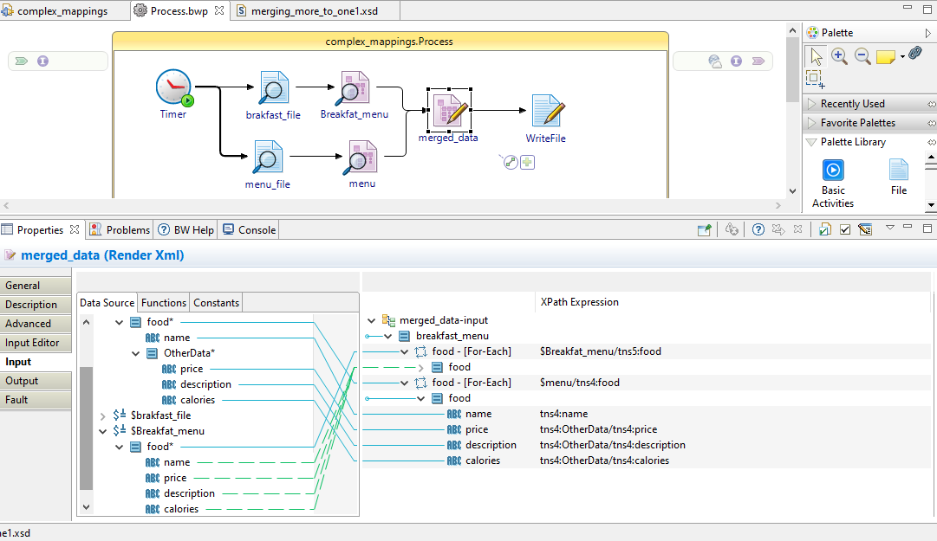

Then we will get output after debugging as below.

<?xml version="1.0" encoding="UTF-8"?>

<tns5:breakfast_menu xmlns:tns5="http://www.example.org/merging_more_to_one1" xmlns:tns4="http://www.example.org/merging_more_to_one2">

<tns5:food>

<tns5:name>Belgian Waffles</tns5:name>

<tns5:price>$5.95</tns5:price>

<tns5:description>Two of our famous Belgian Waffles with plenty of real maple syrup</tns5:description>

<tns5:calories>650</tns5:calories>

</tns5:food>

<tns5:food>

<tns5:name>Strawberry Belgian Waffles</tns5:name>

<tns5:price>$7.95</tns5:price>

<tns5:description>Light Belgian waffles covered with strawberries and whipped cream</tns5:description>

<tns5:calories>900</tns5:calories>

</tns5:food>

<tns5:food>

<tns5:name>Berry-Berry Belgian Waffles</tns5:name>

<tns5:price>$8.95</tns5:price>

<tns5:description>Light Belgian waffles covered with an assortment of fresh berries and whipped cream</tns5:description>

<tns5:calories>900</tns5:calories>

</tns5:food>

<tns5:food>

<tns5:name>French Toast</tns5:name>

<tns5:price>$4.50</tns5:price>

<tns5:description>Thick slices made from our homemade sourdough bread</tns5:description>

<tns5:calories>600</tns5:calories>

</tns5:food>

<tns5:food>

<tns5:name>Homestyle Breakfast</tns5:name>

<tns5:price>$6.95</tns5:price>

<tns5:description>Two eggs, bacon or sausage, toast, and our ever-popular hash browns</tns5:description>

<tns5:calories>950</tns5:calories>

</tns5:food>

<tns5:food>

<tns5:name>Waffles</tns5:name>

<tns5:price>$5.95</tns5:price>

<tns5:description>Two of our famous Belgian Waffles with plenty of real maple syrup</tns5:description>

<tns5:calories>650</tns5:calories>

</tns5:food>

<tns5:food>

<tns5:name>Strawberry</tns5:name>

<tns5:price>$7.95</tns5:price>

<tns5:description>Light Belgian waffles covered with strawberries and whipped cream</tns5:description>

<tns5:calories>900</tns5:calories>

</tns5:food>

<tns5:food>

<tns5:name>Berry-Berry</tns5:name>

<tns5:price>$8.95</tns5:price>

<tns5:description>Light Belgian waffles covered with an assortment of fresh berries and whipped cream</tns5:description>

<tns5:calories>900</tns5:calories>

</tns5:food>

<tns5:food>

<tns5:name>French</tns5:name>

<tns5:price>$4.50</tns5:price>

<tns5:description>Thick slices made from our homemade sourdough bread</tns5:description>

<tns5:calories>600</tns5:calories>

</tns5:food>

<tns5:food>

<tns5:name>LITE Breakfast</tns5:name>

<tns5:price>$6.95</tns5:price>

<tns5:description>Two eggs, bacon or sausage, toast, and our ever-popular hash browns</tns5:description>

<tns5:calories>950</tns5:calories>

</tns5:food>

</tns5:breakfast_menu>

If doesn’t tke on for each on menu mapping then we will get data as below.

<?xml version="1.0" encoding="UTF-8"?>

<tns5:breakfast_menu xmlns:tns5="http://www.example.org/merging_more_to_one1" xmlns:tns4="http://www.example.org/merging_more_to_one2">

<tns5:food>

<tns5:name>Belgian Waffles</tns5:name>

<tns5:price>$5.95</tns5:price>

<tns5:description>Two of our famous Belgian Waffles with plenty of real maple syrup</tns5:description>

<tns5:calories>650</tns5:calories>

</tns5:food>

<tns5:food>

<tns5:name>Strawberry Belgian Waffles</tns5:name>

<tns5:price>$7.95</tns5:price>

<tns5:description>Light Belgian waffles covered with strawberries and whipped cream</tns5:description>

<tns5:calories>900</tns5:calories>

</tns5:food>

<tns5:food>

<tns5:name>Berry-Berry Belgian Waffles</tns5:name>

<tns5:price>$8.95</tns5:price>

<tns5:description>Light Belgian waffles covered with an assortment of fresh berries and whipped cream</tns5:description>

<tns5:calories>900</tns5:calories>

</tns5:food>

<tns5:food>

<tns5:name>French Toast</tns5:name>

<tns5:price>$4.50</tns5:price>

<tns5:description>Thick slices made from our homemade sourdough bread</tns5:description>

<tns5:calories>600</tns5:calories>

</tns5:food>

<tns5:food>

<tns5:name>Homestyle Breakfast</tns5:name>

<tns5:price>$6.95</tns5:price>

<tns5:description>Two eggs, bacon or sausage, toast, and our ever-popular hash browns</tns5:description>

<tns5:calories>950</tns5:calories>

</tns5:food>

<tns5:food>

<tns5:name>Waffles Strawberry Berry-Berry French LITE Breakfast</tns5:name>

<tns5:price>$5.95 $7.95 $8.95 $4.50 $6.95</tns5:price>

<tns5:description>Two of our famous Belgian Waffles with plenty of real maple syrup Light Belgian waffles covered with strawberries and whipped cream Light Belgian waffles covered with an assortment of fresh berries and whipped cream Thick slices made from our homemade sourdough bread Two eggs, bacon or sausage, toast, and our ever-popular hash browns</tns5:description>

<tns5:calories>650 900 900 600 950</tns5:calories>

</tns5:food>

</tns5:breakfast_menu>